Lab 02 – Pre-Lab

Rectification
Name: Syed Sualeh Abbas | Student ID: 10303

Objective
Investigate the performance of half-wave and full-wave rectification circuits implemented using diode

Pre-Lab Task
Read up a bit on Rectification if you are not quite aware of what the term means. We will be discussing in detail about the concept during class, but the Prelab can be completed with the understanding of the basics of the concept.

Task 1: To simulate half-wave rectifier circuit using PSpice
Figure 1 shown implementation of half-wave rectifier circuit in OrCAD PSpice. Here, an AC voltage source is connected to a step-down transformer (240V/24V). The AC voltage source of 240V with 50 Hz frequency simulates supply from outlet at your home. The amplitude is reduced down using a step-down transformer. Usually, the required output of DC power supply is not as high as 240V therefore, before rectification, the amplitude of AC signal is stepped down.
Figure 1: Schematic for simulation of half-wave rectifier circuit
- Implement the circuit using OrCAD Capture. PSpice model name of the AC voltage source is VSIN. To add a transformer, go to Place> PSpice Component > Modelling Application > System Modules > Transformer. Make sure Two Winding is selected. In listed properties, change turns ration to 0.1 i.e. the secondary voltage is 10 times lesser than the primary voltage. At the output terminals, connect a load resistor of 1kΩ through a half-wave rectifier (diode model 1N4007).
- Run Transient Analysis and set run time to 0.2sec to at least view 10 cycles of AC supply. Set the value of maximum step size to 0.001sec, in order to get a smoother waveform.
- Obtain waveforms of voltage across load, voltage across diode (using differential voltage markers) and secondary voltage of transformer. Obtain current waveform in a separate window. Add captures of the obtained plots.
- 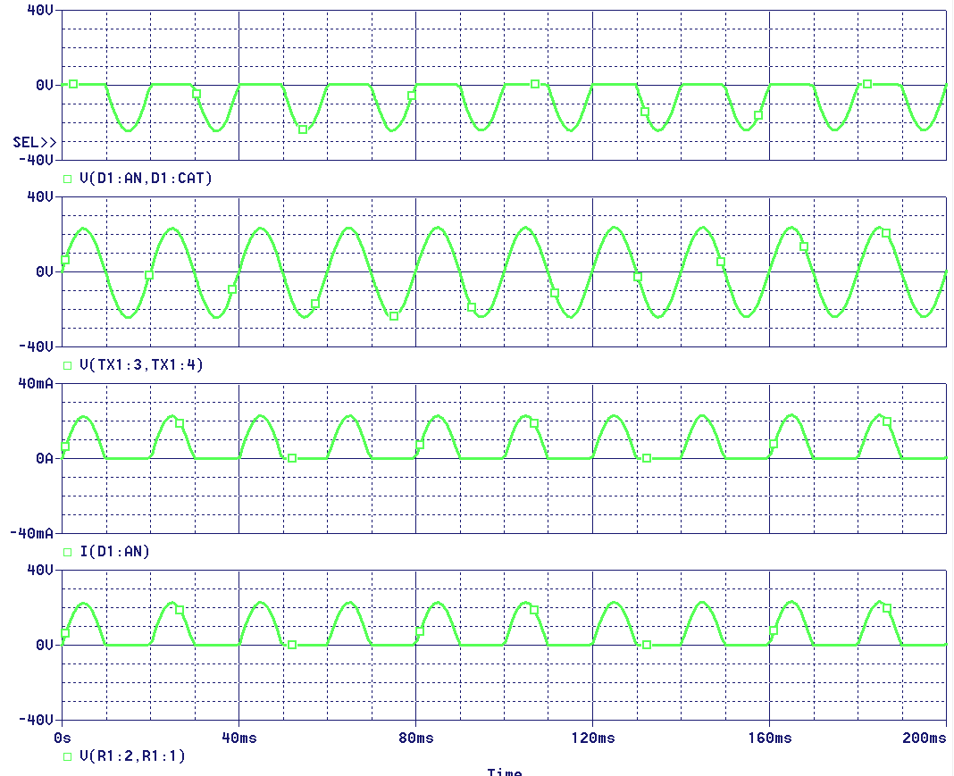In which half cycle of the supply, the diode conducts? Explain how you can identify the conduction of diode from the obtained waveforms.
In the positive half cycle the diode conducts current, as we can see the current only passes through the diode when the voltage through secondary coil is in its positive half.
- Can we say that the circuit works as a rectifier? Justify your answer. Why this rectifier is called half-wave rectifier?
Yes, we can say the circuit works a s a rectifier because it changes the voltage to unidirectional. The ac signal has two halves, one is positive half, the second is negative half. So as out circuit only passes the positive half and blocks the negative half, its called half wave rectifier.
- For the obtained output voltage, measure the parameters listed in Table 2.1.
PSpice Measurement Help:
- To add plots for RMS (Root Mean Square) and average values of the output voltage, go to Trace > Add Trace. In Add Traces Window, you will see Functions listed at right hand side. Select RMS ( ). In parenthesis, write the expression of output voltage V (R1:2 - R1:1) where, terminal 2 of R is connected to ground. Discard starting few cycles, consider the waveform when voltage becomes stable.
- Similarly, add trace for average value by selecting AVG ( ) from functions. In parenthesis, write the expression of output voltage V (R1:2 - R1:1) where, terminal 1 of R is connected to ground.
For example: AVG(V (R1:2) -V (R1:1)).
- Exact value can be read using cursors for the added traces. When measuring the values, ignore the first few cycles.
- Frequency can be calculated by measuring the time period of waveforms.
- Table 2.1: Performance parameters of half-wave and full-wave rectifiers
Parameters | Half-wave Rectifier | Full-wave Center Tapped Rectifier | Full-wave Bridge Rectifier | Full-wave Bridge Rectifier with Filter
Input Frequency: f_{in} | 50 | 50Hz | 50Hz | 50Hz
Output Frequency: f_{o} | 49.50 | 100Hz | 100Hz | 100Hz
Output DC Voltage: V_{dc}  _{(Mean value – DC coupling)} | 7.5V | 21V | 20V | 32.4V
Output RMS Voltage (AC): V_{RMS (AC coupling only)} | - | 10.24V | 9.8V | 0.079V
Output RMS Voltage (Total i.e., AC+DC): V_{RMS (DC coupling)} | 11.52 | 23V | 23V | 32.5V
Ripple Factor: γ | 1.29 | 0.5 | 0.47 | 0.0025

